Reflective Portfolio:
Introduction:
The Higher Education Academy (2014) defines student experience as being the “totality of a student’s interaction with the institution” usually through an association with a Students’ Union (SU). SU’s are “student-run groups” that dedicate both their “time and resources” to provide the community of university students with “opportunities and a voice” (UniversityCompare:2020) to “enhance the student experience” (Beech:2018).
The student experience is divided into four key components with the SU’s associating with the component of ‘campus experience’. The campus experience focuses on the aspects of student life that are “not directly connected with study” (Callender, Grove, Temple et al. 2014), it can include activities organised away from the actual campus or using campus facilities to operate societies and sports clubs. In this portfolio, I will be reflecting on the importance of Student Union’s within universities and their overall contribution to the student experience by exploring my role as President of Coventry University’s Musical Theatre Society (CUSU MTS).

1: Critically reflect on the contribution that sports and societies make to the student experience at Coventry University:
To enhance the campus experience of a student’s university journey, Coventry University offer various resources and programmes that students can take part in to feel more involved and enhance their overall university experience. The National Union of Students (NUS) is an organisation that “champion students to shape the future of education” (SU People:2018) by ensuring Student Unions across the UK follow and uphold the core values of “equality, democracy and collectivism”.
Being “a charity that exists to improve the experience of students” (CUSU:2020), CUSU upholds the values of the NUS by chiefly ensuring it “represents the interests of all students at the local and national level” (Coventry University:2020). The university’s student charter outlines CUSU’s aims and expectations demonstrated through its positive impact upon students and campus life.
In my first year of university (2018), I decided to join CUSU’s Musical Theatre Society as I initially wanted to feel more involved and enrich my time at university and I felt joining a society would act as an outlet from constantly working on my degree whilst encouraging me to socialise with people who shared similar interests. Upon joining the society, I was able to divide my time between working on my degree and working towards the society’s showcase, which in turn enabled me to socialise and learn more about the society.
In 2020, I decided to run for President as I had experienced the role of a cast member thoroughly and wanted to explore the society from the perspective of a committee member. The prospect of taking on a leadership role was a catalyst in my decision making, alongside my wanting to give back to my society. The SWOT Analysis framework is a popular strategy tool globally used to measure an organisation’s development through the division of strengths, weaknesses, opportunities and threats (Mindtools n.d.). The framework uses a “chain of reasoning” (Puyt:2020) to maintain success and enable improvement within organisations and can be applied when measuring the development of CUSU MTS and whether the society meets the expectations of students and the SU.

INTERNAL
Weakness:
- Poor social media presence
- Lack of technical workshops
- Cast size is too large for current venues and rehearsal spaces
- Roles extraneous to requirements
Strengths:
- Provides social aspect to students
- Builds on employability skills
- Annual showcases/fieldtrips
- Creating a fun/engaging atmosphere
- Pastoral support for mental health and physical wellbeing
N
E
G
A
T
I
V
E
P
O
S
I
T
I
V
E
EXTERNAL
Threats:
- Other competing societies
- Covid-19
- Being denied rehearsal space within university buildings
Opportunities:
- Sponsorships
- Social media pages/blog posts
- Guest speakers at workshops
- Fieldtrips (West End)/After parties
- Merchandise competitions (pins, t-shirts, hoodies)

Figure 1
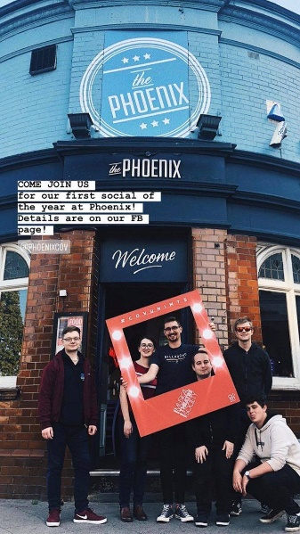
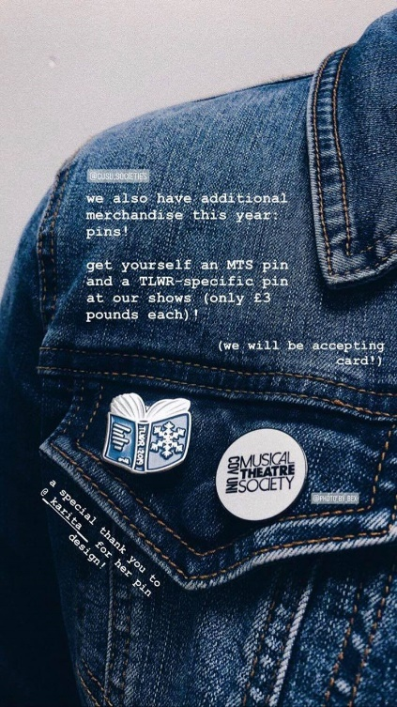
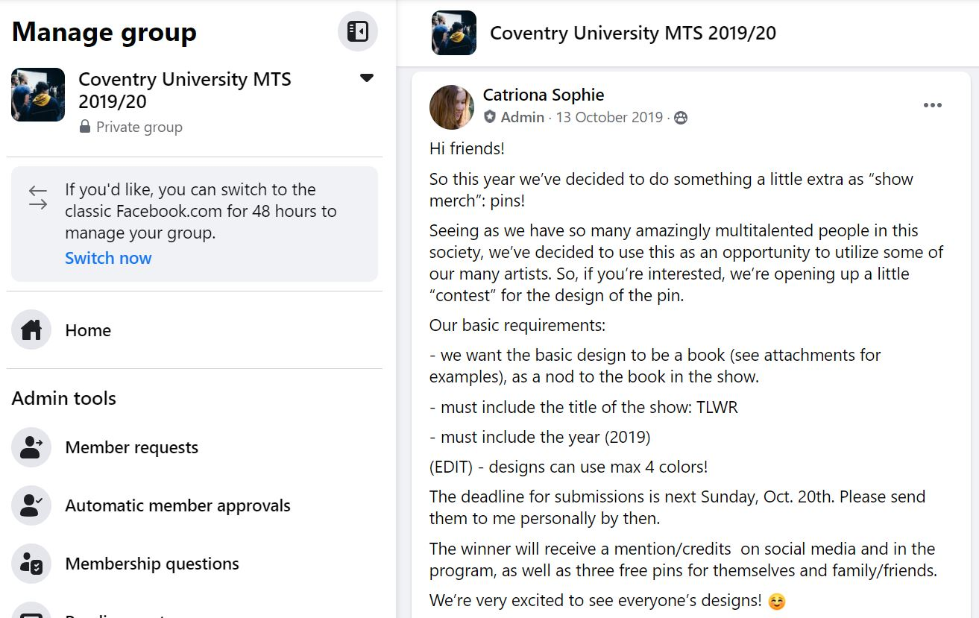
By looking at the SWOT analysis [figure 1], our strengths section indicates the society’s ability to provide an environment that fulfils the initial expectations of prospective members. Students join sports clubs and societies as a way to “widen their social network beyond their course and people they live with” and to meet people who share similar interests with them (All About Careers:2020). MTS meets the value of collectivism by creating a fun and engaging environment with the use of ice-breakers to introduce and involve members into the cohort. This is maintained with socials outside of our society rehearsal times, where members can socialise in a relaxed environment and form friendships [figure 2].
Whilst we succeed in creating a positive atmosphere within our rehearsals, our society’s poor social media presence struggles to market the content of what happens in the society. A solution to this could be opening the platform out to the society, where members could do take-over days to showcase their interests and opinions surrounding theatre and the society as a whole on social media. This would make members feel more involved and encourage them to socialise and support each other’s ideas whilst ensuring the social media platforms remain active.
MTS is comprised of predominantly creative individuals who are able to utilise our platform by entering our competitions [figure 3] to design badges, show posters and programmes, used as marketing materials throughout the year [figure 4]. Being one of few performance societies at Coventry University, this unique opportunity enhances the experience of members and enables them to utilise their membership in a way no other society can offer.
Figure 2
Figure 4
Figure 3

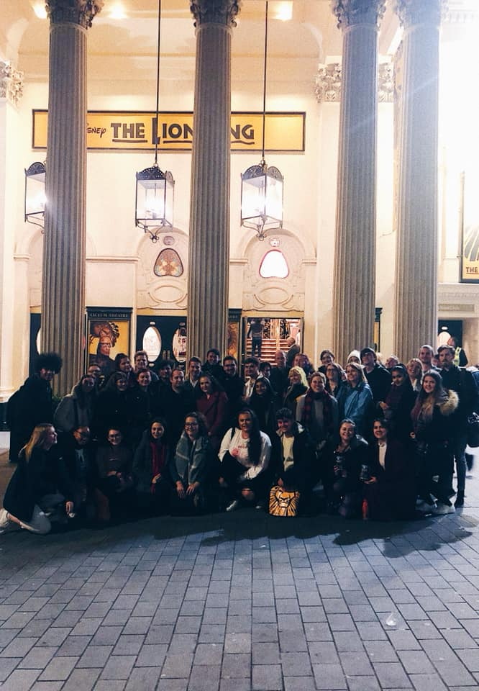
Our steadily increasing financial reserve has enabled us to offer all our members cost-covered field trips to the West End (Lion King 2019), where members can socialise and indulge in their passion for theatre [figure 5]. The largest threat out society faces this year is Covid-19 as it has prevented face-to-face activities, trips and hosting a winter showcase. These restrictions have made it difficult to engage members with the society and have negatively affected group morale. We have attempted to combat this by promoting mindfulness resources to members throughout the lockdown.
Overall, despite uncontrollable factors, MTS aims to provide a positive environment to its members whilst meeting the aims of CUSU by meeting student’s initial expectations, enriching their experience and celebrating their interests (Coventry University:2020). Our society also upholds the core values of NUS as we open our society to all abilities, run democratic elections for committee roles and maintain an inclusive and engaging environment that supports all our members equally.
Figure 5

2: Formulate SMART recommendations for the development of your sport club/society at Coventry University SU:
Leadership is a “process whereby an individual influences a group of individuals to achieve a common goal” (Northouse:2012), it can be defined into various styles usually based on the type of goal being set out to achieve. SMART recommendations are an important way development targets are met within an organisation and leaders chiefly ensure these recommendations are met. In the past, MTS has worked towards fulfilling ambiguous targets that lack specific recognition of the society’s weaker aspects, ultimately hindering the progress required for the growth of the society. By creating SMART recommendations, as President, I am able to recognise the areas of improvement and how they can be achieved in a more detailed format compared to previous years.
Figure 6
SPECIFIC | MEASURABLE | ATTAINABLE | RELEVANT | TRACKABLE
Developing and maintaining relationships with musicians. | An increase in musicians joining or affiliating with the society.  2 active musicians  2 alumni musicians  No Musical Director | It is achievable due to our society’s musicians having friends who are musicians.  Creative Assistant, President, Inclusions officer | We currently have no live band or MD and therefore our need to maintain relationships with current musicians is crucial for future years. | Next year’s committee will have a live band and MD.
Increase the quality of technical resources, set and costumes. | By setting aside a substantial budget from the financial reserve.  2019-20: £200 for tech budget (Winter Showcase)  2020-21:£250-300 (approx.) required for technical resources repairs [excluding show budget] | Due to Covid-19 restrictions we cancelled our 2020-21 Winter Showcase and therefore there has been a saving in the financial reserve.  Show budget can be used for repairs and replacements.  Treasurer | We currently have a qualified Technical Director on our committee who is able to source affordable and long-lasting equipment for the future years of the society. | Our current Technical Director will have created a document outlining the details of the stock and future replacement dates.  This will be passed onto the future Technical Director.
Ensuring F2F activities remain Covid-19 friendly. | Society PPE kit at all rehearsals, using track and trace system and noting down attending member’s temperature on arrival by either session leaders or Covid Officer (myself). | By continuously ensuring that members come into the space wearing face-coverings and without symptoms.  Spaces must be cleaned down before, during and after use.  Low number of active members means social distancing can be maintained in spaces.  President/Inclusions | The pandemic is a constantly changing and unpredictable situation and therefore long-term precautions need to be set out to ensure F2F activities can run smoothly.  This is both a short/long-term goal. | Using the track and trace, frequently reviewed post-session reports to the SU, society feedback and following the Government Guidelines, we will be able to ensure that all members who attend F2F activities are safe and can attend the session without a high risk of being exposed to the virus.
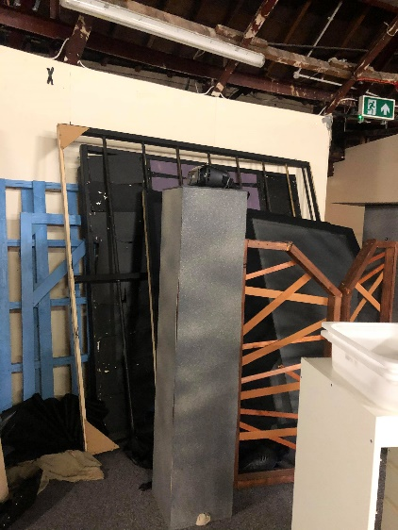
Our first SMART target is to develop and maintain our society’s relationship with musicians, to ensure the society is able to continue to support its future shows with a live band and Musical Director. By building a rapport with new MTS members, other musically based societies and our alumni, we can attain this goal and ensure the society upholds its present show quality, by preventing the reversion to backing-tracks. Another way of reaching out to potential musicians within the society is by hosting a virtual connections evening. This networking opportunity will kickstart communication between musicians with links to MTS and other musical based societies, potentially increase the society’s number of active musicians and eventually fill the position of MD in the society.
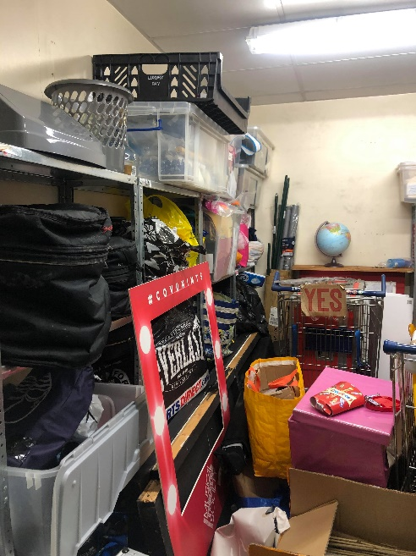
Our second SMART target is to increase the quality of our technical equipment, set and costume pieces, a goal attainable only by investing in an independent storage unit. A recent stock take of our society’s inventory [figure 7 &8] indicated that most of our costumes are outdated and need to be discarded for hygiene purposes. Furthermore, our previously purchased technical equipment and set pieces are quite large, expensive and difficult to source and moving them to a more secure space will prevent them being used or damaged by other societies or students who have access to our current shared storage spaces [figures 9, 10, 11 & 12]. Our goal is attainable as most of our financial reserve will remain unused this year due to the restrictions in place as a result of the pandemic, enabling an increase in budget for tech repairs, set and costume replacement and investment into an appropriate storage space. By investing in an independent storage unit, we will be able to manage our stock more efficiently and ensure that it can be preserved for future years to use, making it a cost-effective investment.
Figure 7
Figure 9
Figure 8
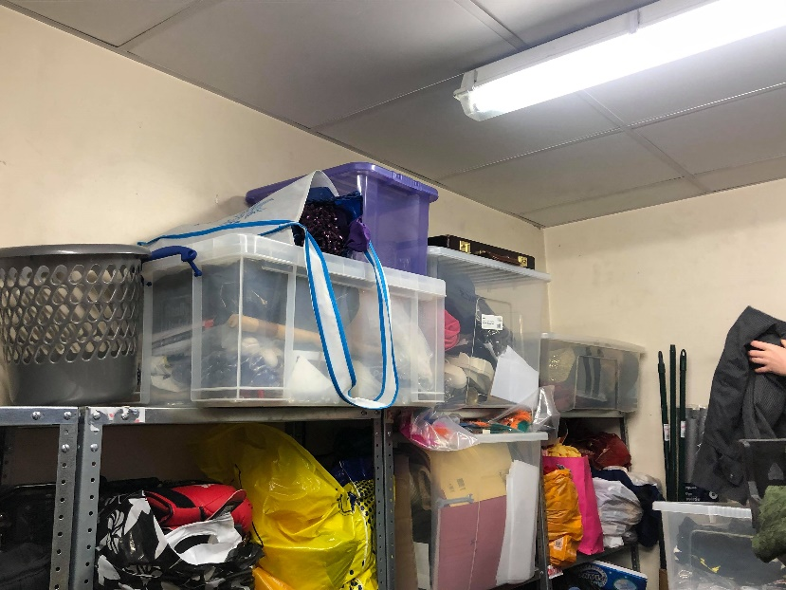
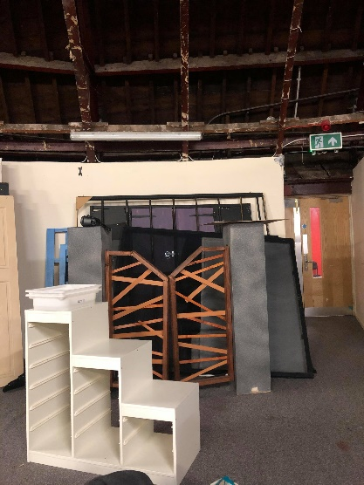
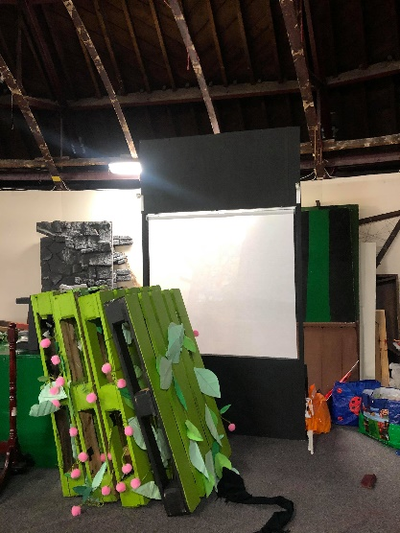

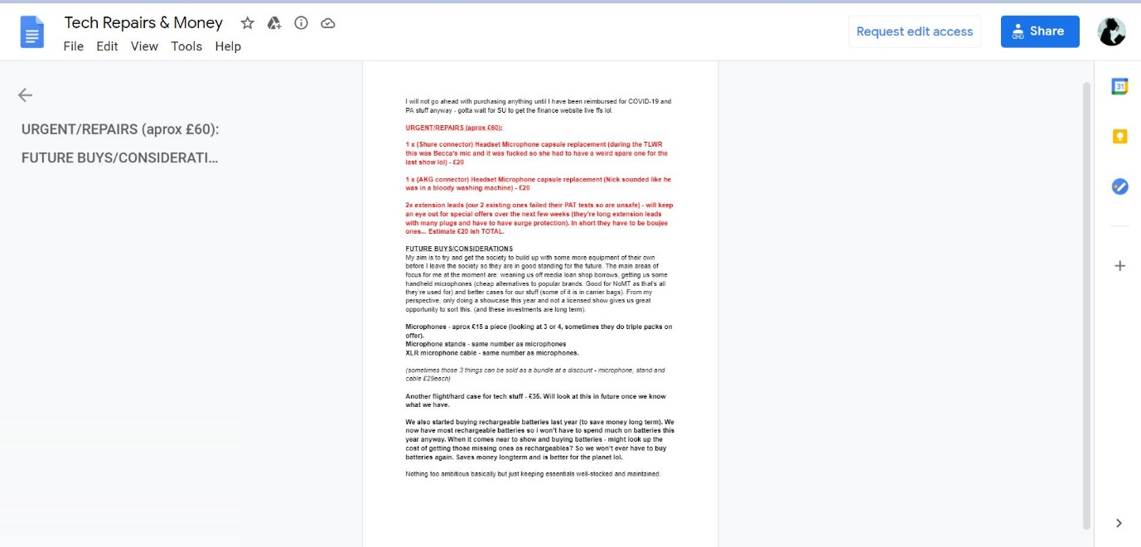
Figure 12
Figure 11
Figure 10
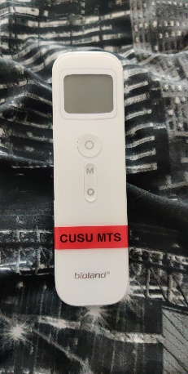
Our third SMART target of ensuring member safety during Covid-19, serves as a long-term goal that will be implemented once F2F activities resume. MTS will enforce government guidelines and expect members to adhere to all precautions and regulations, which include but are not limited to; all members must social distance and wear face coverings (except during performance activities) once in the space. Upon arrival, all members must sign into the society’s ‘track & trace’ system and undergo a temperature check [figure 13] and regularly wash their hands throughout the session. Committee members will be expected to clean the space before, during and after the session using the wipes and anti-bacterial sprays and will have access to hand sanitizer and latex gloves [figure 14].
Due to the fluctuance of the pandemic, it is important to prioritise the mental wellbeing and health of members during F2F activities. Performance based societies have an increased productivity rate from in-person sessions compared to online ones and the implementation of these restrictions will reduce the risk of spreading and contracting coronavirus. The progression of this SMART recommendation will be measured and tracked through frequently reviewed post-session reports and feedback from society members.
Figure 13
Figure 14
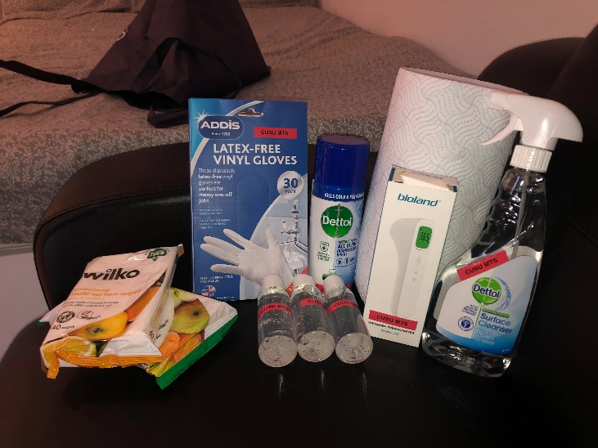
SMART recommendations are an effective tool to monitor progression within the society and are useful for improving weaker aspects of the society. The role of President requires strong leadership skills which I have displayed through my communication and task delegation within committee, remaining organised and informed of updates surrounding the operation of the society and being a positive figure for the society. Along with myself, I have encouraged select committee members (Artistic Director and Inclusions/Social Officer) to nominate themselves for the CUSU Leadership Award [figure 15] as a way to recognise their efforts as leaders within the society.
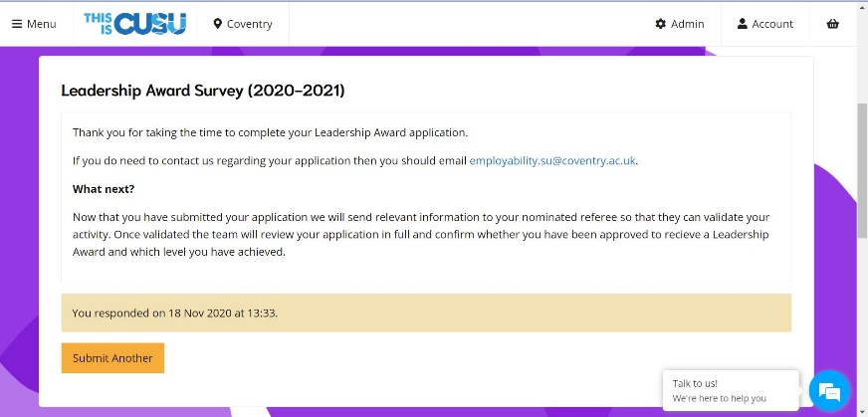

Figure 15
3: Critically reflect on your own contribution to your sport club/society and how it has developed your employability skills:
Transferrable skills are “skills and abilities that are helpful and relevant across all areas of life” (Skills You Need:2020), particularly in social and professional settings. Being part of CUSU Musical Theatre Society as a cast member (2018-20) and Society President (2020-21), I have developed various transferrable skills that have enhanced my employability [figure 16].
As a cast member, I was expected to frequently attend and participate in rehearsals, however as President I have become the bridge between the committee and the SU, the society’s third party representative (Musical Theatre International [MTI], sponsorships, merchandise companies), undertaken event planning (paperwork, finance, venue sourcing and F2F space sourcing), safeguarding of members/implementing disciplinary actions and ensuring the society makes steady improvement during my time as President.
Employability Skill | Contribution to develop the skill
communication | - Announcements/reminders to society members via zoom, in-person, the group chat and posts in private FB group  - Liaising with committee [committee meetings, Teams Drive]  - Being the liaison between committee and SU [email]  - Contacting third party organisations (sponsorship, MTI, merchandise companies) [email/drop-ins/phone]  - Supporting with inclusions issues [being empathetic and working with discretion]
organisation | - Taking the committee meeting minutes  - Creating and uploading relevant documents and information to the Teams Drive  - Organising and supervising stock take  - Organising and reminding relevant members of membership, contracts, surveys, committee feedback, PPE, training sessions etc
leadership | - Managing a committee [displayed through my Leadership Award application]  - Delegating tasks between relevant committee members  - Chairing committee meetings  - Informing committee of updates and information regarding the society [F2F spaces]  - Making decisions [cancellation of show, workshops]
teamwork | - Managing committee [weekly committee meetings, progress reports]  - Supporting other committee members in their role (finance and budgeting plans, marketing and helping to run the minisite, co-hosting socials, supporting inclusions officer)  - Organising and supervising stock take (set, costume and tech)  - Helping to develop ideas with the admin/creative team  - As a cast member, working with other actors on scenes and working together on teams in socials
technological skills | - Managing the committee Teams Drive  - Using online platforms to operate [zoom, Microsoft teams]  - Helping to run the minisite  - Running the society email
time management | - Attending rehearsals, organising and attending committee meetings/training sessions  - Balancing the responsibility of being President, being present in sessions with my university workload and personal life without becoming overwhelmed  - Completing tasks within an appropriate time frame [deadlines set by the SU]  - Setting deadlines to committee members to complete tasks to ensure everything is prioritised appropriately
Figure 16

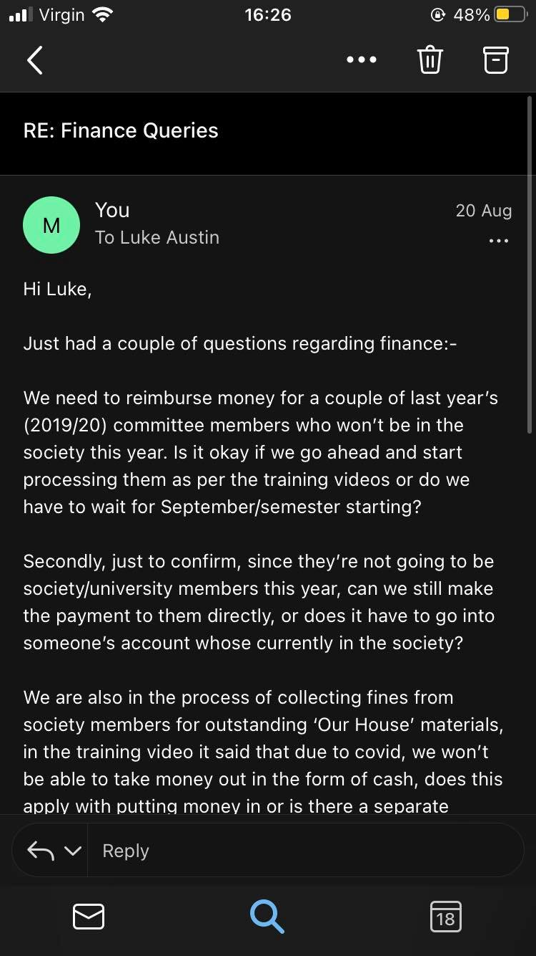
Communication skills are the key to building relationships and effective communication derives from your ability to change your style accordingly (amanadawright recruitment:2020). As the society’s communication bridge to the SU and other organisations, it is important that I am able to adapt my language style and approach based on the form of communication and to whom.
When emailing the SU, I am concise and informative to create a coherent and easily understood email, ensuring that my queries are answered and resolved efficiently [figure 19]. I adopt a similar technique when emailing MTI or making in-person visits to sponsorship venues, however, I use the relevant jargon and adopt a more formalised tone to give the impression that despite being a university society, we are professional and require efficient results [figure 17].
This contrasts with my communication techniques to society members where I adopt a more informal and friendly tone as I want to appear approachable and create a safe and enjoyable environment when making announcements to the cohort [figure 18].
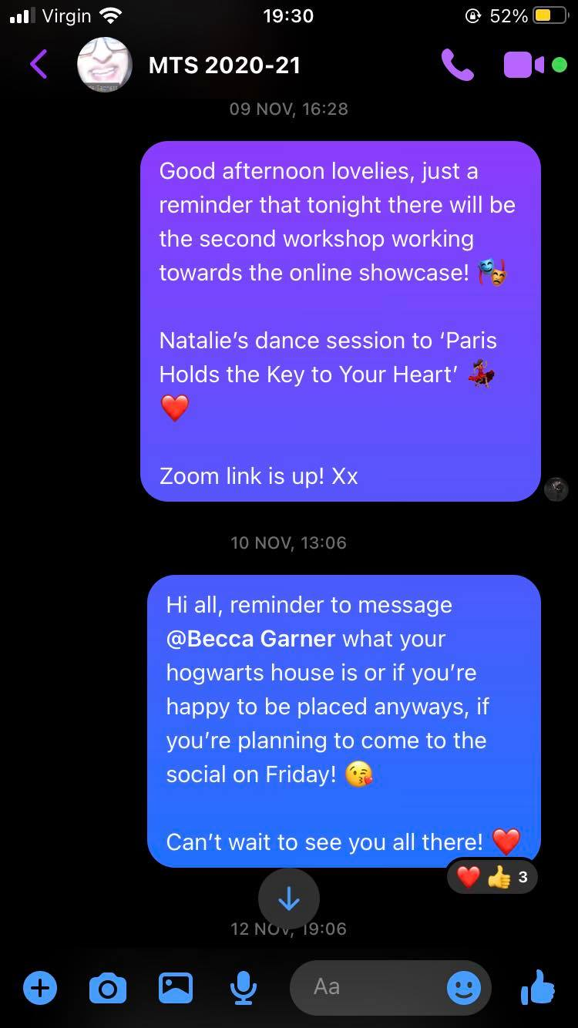
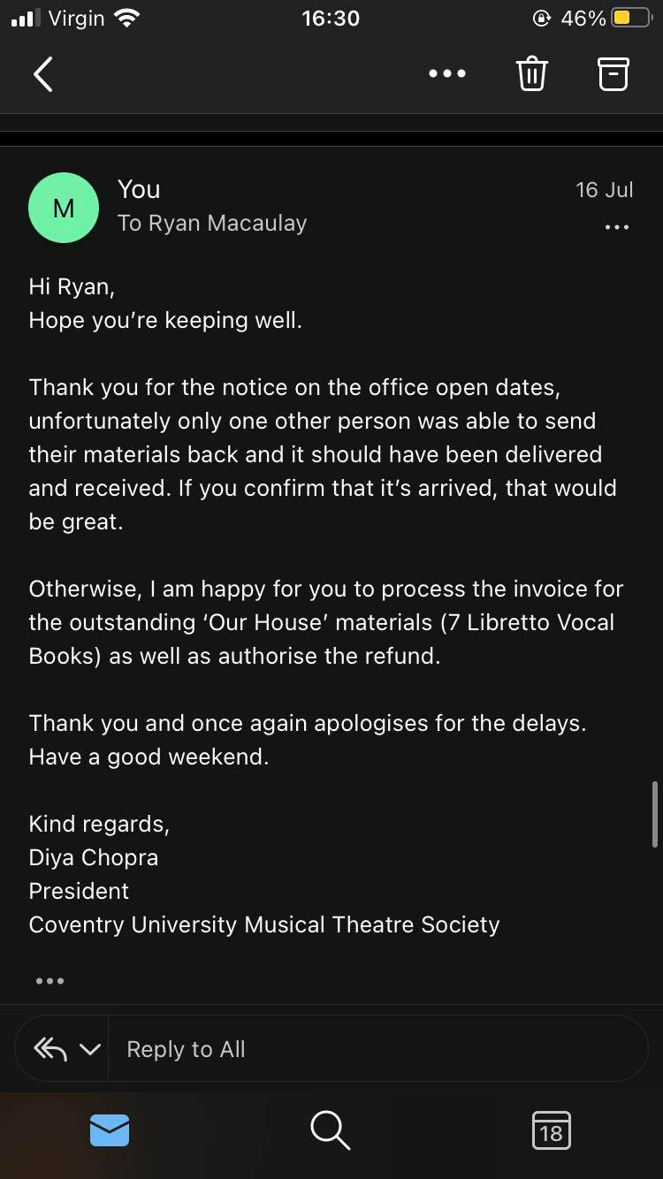
Figure 17
Figure 19
Figure 18

I have developed my organisation skills through my approach as President by scheduling weekly reminders to the committee and society regarding sessions, meetings and socials. These weekly reminders ensure all members are aware of the upcoming events and prompt committee members of the tasks they need to complete for each week. As President, I organise our weekly committee meetings, manage stock taking days, committee feedback, extra events and venue sourcing which require planning a key organisation skill. Further examples of my organisational skills are displayed through my responsibility of taking committee meeting minutes, our committee Teams Drive and tracking attendance in correspondence to memberships.
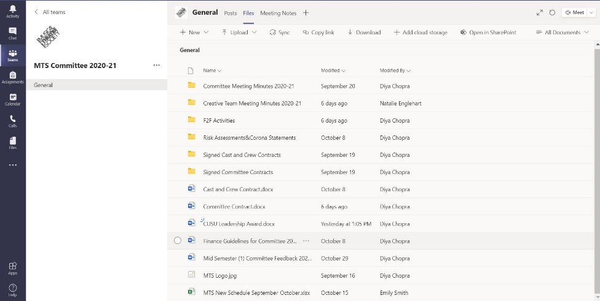
As President, I have implemented the use of a shared Teams Drive [figure 20] where committee members can access and upload documents, relevant to the functioning of the society. The implementation of this drive has enabled me to develop my organisational, teamwork, leadership and technological skills. Having a Teams Drive is useful and has received positive feedback as it enables the committee to easily access information packs, schedules, training slides, contracts and meeting minutes from one universal space.

Figure 20
Throughout my time in MTS, I have been presented with opportunities where I have been able to develop my time management skills. As a cast member, I was consistently punctual to all scheduled rehearsals as working in a group requires relying on others and being able to fulfil commitments. As President, upholding good time management is crucial in my role as a leader.
Developing my time management skills has taught me to prioritise and schedule my tasks when having to balance my responsibilities as President, my university workload and personal life to prevent myself from neglecting my duties or feeling overwhelmed.
In my opinion, my time with CUSU MTS has provided me with the opportunity to enhance my university experience whilst developing my employability skills, beneficial for any chosen career path. I would recommend university students to join a society as the skills, experience and growth you attain are unique and rewarding and have a positive contribution to your university career.

References:
All About Careers (2020) Benefits of Joining a Society [online] available from <https://www.allaboutcareers.com/careers-advice/university-societies/benefits-of-joining-a-student-society#:~:text=The%20obvious%20benefit%20of%20joining,the%20people%20you%20live%20with> [19 November 2020]
Amanda Wright Recruitment (2020) Why Employability Skills are Important? [online] available from <https://www.amandawright-rec.co.uk/latest-news/why-are-employability-skills-important/57> [18 November 2020]
Beech, D. (2008) Students Union in a Changing World [online presentation] National Union of Student’s Chief Executive Networking Event, 22 January 2018. Leeds: Leeds University. available from <https://www.hepi.ac.uk/2018/01/22/students-unions-changing-world/> [18 November 2020]
Callender, C. Grove, L. Temple, P. et al. (2014) Managing the Student Experience in a shifting higher education landscape [online] York: The Higher Education Academy. available from <https://s3.eu-west-2.amazonaws.com/assets.creode.advancehe-document-manager/documents/hea/private/resources/managing_the_student_experience_1568037252.pdf> [19 November 2020]
Coventry University (2020) Commitments and Expectations [online] available from <https://www.coventry.ac.uk/life-on-campus/our-student-charter/commitments-and-expectations/> [19 November 2020]
CUSU (2020) How the Union Works [online] available from <https://www.cusu.org/theunion/> [18 November 2020]
Mindtools (n.d.) SWOT Analysis Inforgraphic [online] available from <https://www.mindtools.com/pages/article/newTMC_05.htm#:~:text=SWOT%20Analysis%20is%20a%20simple,advantage%20of%20chances%20for%20success> [19 November 2020]
Northhouse, P. (2012) Leadership: Theory and Practice. Los Angeles: Sage Publications
NUS (2020) Who we are? [online] available from <https://www.nusconnect.org.uk/nus-uk/who-we-are> [19 November 2020]
Puyt, R. (2020) ‘Origins of SWOT Analysis’ Academy of Management Proceedings [online] 2020 (1), 1-6. available from <https://journals.aom.org/doi/epdf/10.5465/AMBPP.2020.132> [19 November 2020]
Skills You Need (2020) Transferable Skills [online] available from <https://www.skillsyouneed.com/general/transferable-skills.html> [18 November 2020]
SU People (2018) NUS [online] available from <https://www.supeople.com/context/nus/> [19 November 2020]
University Compare (2020) What is a Student Union? [online] available from <https://universitycompare.com/advice/student/student-union/#:~:text=A%20student%20union%2C%20or%20association,fairness%2C%20opportunities%20and%20a%20voice> [11 November 2020]

Figures List:
Figure 1: SWOT Analysis Table for Musical Theatre Society
Figure 2: Photograph of Musical Theatre Society (2019-20) Cast & Committee Members outside Society Sponsorship Venue
[Photograph featured on CUSU MTS Instagram Page]
Figure 3: Screengrab of Competition Announcement for Show Pins from Society Private FB Page (2019-20)
Figure 4: Photograph of Musical Theatre Society (2019-20) Showcase and Society Pins
[Photograph featured on CUSU MTS Instagram Page]
Figure 5: Photograph of Musical Theatre Society (2019-20) Members outside Lyceum Theatre on West End Field Trip
[Photograph featured on CUSU MTS Instagram Page]
Figure 6: SMART Analysis Table for Musical Theatre Society
Figure 7 & 8: Photographs of Musical Theatre Society’s (2020-21) Costume Storage (Societies Cupboard)
Figure 9, 10 & 11: Photographs of Musical Theatre Society’s (2020-21) Set Pieces (ET Dome)
Figure 12: Screengrab of tech repairs and replacements for Musical Theatre Society (2020-21)
Figure 13: Photograph of Musical Theatre Society (2020-21) Temperature Gun as part of PPE
Figure 14: Photograph of Musical Theatre Society (2020-21) PPE available at all F2F sessions
Figure 15: Screengrab of completed CUSU Leadership Aware (2020-21)
Figure 16: Employability Skills Table with examples
Figure 17: Screengrab of email to MTI
Figure 18: Screengrab of reminder/announcements made to Society
Figure 19: Screengrab of email to SU
Figure 20: Screengrab of the Committee Teams Drive

